Electrochemical behavior of dissimilar welded joints between ASTM A615 and AISI 304 with and without buttering using Inconel 182

J. C. I Ramirez –Soto¹* , J. T. Pérez-Quiroz² , J. M. Salgado-López³ , M. Martinez-Madrid² , T. Pérez-López¹ , M. Rendón-Belmonte² , E. Alvarez-Alfaro⁴
*Contact author: autor.contacto@email.com
DOI: 334

Reception: 16/07/2019 | Acceptance: 04/03/2019 | Publication: 30/04/2019

ABSTRACT
In this study, the corrosion performance of dissimilar welded joints between ASTM A615 and AISI 304 stainless steel with and without buttering using Inconel 182 was evaluated. In both cases, the filler metal was ER-309L and the base metals were prepared with a 45° single bevel. One half of the specimens were welded with “buttering” using Inconel 182. The electrochemical results showed that despite welding defects, the welded specimens formed a passive layer in alkaline environments. The specimens welded with buttering exhibited the best corrosion resistance and mechanical properties.
Keywords: corrosion; dissimilar welding; infrastructure.
Cite as: J. C. I Ramirez –Soto, J. T. Pérez-Quiroz, J. M. Salgado-López, M. Martinez-Madrid, T. Pérez-López, M. Rendón-Belmonte, E. Alvarez-Alfaro (2019), “Electrochemical behavior of dissimilar welded joints between ASTM A615 and AISI 304 with and without buttering using Inconel 182”, Revista ALCONPAT, 9 (2), pp. x-x., DOI:334

_______________________________________________________________
¹ Centro de Investigaciones en Corrosión, México.
² Instituto Mexicano del Transporte, México.
³ Tecnología de Materiales, México.
⁴ Tecnológico Nacional de México Instituto Tecnológico de Querétaro, México.

Legal Information
Revista ALCONPAT is a quarterly publication by the Asociación Latinoamericana de Control de Calidad, Patología y Recuperación de la Construcción, Internacional, A.C., Km. 6 antigua carretera a Progreso, Mérida, Yucatán, 97310, Tel.5219997385893, alconpat.int@gmail.com, Website: www.alconpat.org
Responsible editor: Pedro Castro Borges, Ph.D. Reservation of rights for exclusive use No.04-2013-011717330300-203, and ISSN 2007-6835, both granted by the Instituto Nacional de Derecho de Autor. Responsible for the last update of this issue, Informatics Unit ALCONPAT, Elizabeth Sabido Maldonado, Km. 6, antigua carretera a Progreso, Mérida, Yucatán, C.P. 97310.
The views of the authors do not necessarily reflect the position of the editor.
The total or partial reproduction of the contents and images of the publication is strictly prohibited without the previous authorization of ALCONPAT Internacional A.C.
Any dispute, including the replies of the authors, will be published in the first issue of 2020 provided that the information is received before the closing of the third issue of 2019.
Estudio del comportamiento electroquímico de la unión soldada acero ASTM A 615 y acero inoxidable AISI 304 con mantequillado de Inconel 182

RESUMEN
Este trabajo evaluó el desempeño frente a la corrosión de uniones soldadas disimiles, utilizando como metales base acero al carbono ASTM A 615 y acero inoxidable austenítico AISI 304, y como metal de aporte electrodo ER-309L, se utilizó bisel simple a 45°. La mitad de los especímenes fueron sometidos a un proceso de “mantequillado” utilizando electrodo Inconel 182. Los resultados electroquímicos muestran que a pesar de los defectos presentados en la unión soldada, estas tienden a pasivarse en medio alcalino, siendo las probetas con mantequillado las menos deterioradas por efecto de la corrosión y su resistencia mecánica no se ve minimizada.
Palabras clave: corrosión; soldadura disímil; infraestructura.

Estudo do comportamento eletroquímico da junta soldada em aço ASTM A 615 e aço inoxidável AISI 304 com manteiga de Inconel 182
RESUMO
Este trabalho avaliou o desempenho contra a corrosão de juntas soldadas dissimilares, utilizando aço carbono ASTM A 615 e aços inoxidáveis ​​austeníticos AISI 304 como metais básicos, e como metal de enchimento eletrodo ER-309L, utilizando bisel único de 45 °. Metade dos corpos-de-prova foram submetidos a um processo de "manteiga" com eletrodo Inconel 182. Os resultados eletroquímicos mostram que, apesar dos defeitos apresentados na junta soldada, eles tendem a passivar em meio alcalino, sendo os corpos de prova com manteiga menos deteriorado pelo efeito da corrosão.
Palavras-chave: corrosão; soldagem dissimilar; infra-estrutura

- INTRODUCTION

The most common material in construction is reinforced concrete, whose mechanical and chemical properties are important for reliability. However, impairment of concrete structures, which is associated with corrosion in the reinforcement bars, has been reported in the literature (Pérez, 2009). Most bridges and piers in México have been built using concrete reinforced with carbon steel. An exception is the pier in Progreso, Yucatán, and some sections of the pier in Coatzacoalcos, Veracruz. The former uses stainless steel as reinforcement material and the latter galvanized steel. This information indicates that the resistance against aggressive environments is limited (especially in the case of environments with chloride ions and carbon dioxide). Traditionally, different types of methods are applied for counteracting the corrosion damage in concrete structures. Those methods can be classified into four categories based on the protection mechanism (Kepler, 2000):
- Concrete matrix modification
Water/ concrete ratio; Adding cementing materials
- Barrier Methods
Polymer coatings; Paintings; Metallic coatings
- Electrochemical Methods
Cathodic protection by impressed current (ICCP) or galvanic anodes (CPGA); Corrosion inhibitors; Electrochemical extraction of chlorine ions; Electrochemical re-alkalinization.
- Rehabilitation of concrete structures with new materials.
Composite materials, Stainless Steel.
The rehabilitation and refurbishing techniques are many and diverse; some are applied to the steel, others in the concrete, and others in both materials (Gonzalez 2010). The preservation of infrastructure is vital in both economic and social terms, because it provides security and supports social development. However, concrete structures corrode and must be repaired after 10, 20, or 30 years of service because the consequences affect not only the structural integrity but also human safety. Moreover, corrosion reduces the functionality and the value of a structure, leading to large financial expenditures needed to repair, refurbish, or replace the corroded infrastructure. Owing to these reasons, there is a need to develop processes for controlling and preventing corrosion in reinforcement steel bars embedded in concrete structures (Rougier, 2010; Terradillos, 2008). In this way, stainless steel reinforcement bars for concrete structures represent an attractive option that has been proposed for several years in order to increase the endurance of concrete in aggressive environments (BSSA, 2003; Medina, 2013).
Many researchers, for instance Brown (1976), Treadaway (1989), Sorensen (1990), Nurnberger (1996) McDonald (1998), Pedeferri (1997), Bertolini (1998), and Baltazar (2007), have carried out studies to evaluate the behavior of stainless steel as reinforcement material for concrete structures. On the other hand, Lundin, (1982), Doddy, (1992), Ospina, (2007), García (2011), and Pérez-Quiroz (2016) have researched the metallurgy and mechanical properties of dissimilar welded joints, and their results demonstrated that the application of these joints is feasible for refurbishing concrete structures. Considering that stainless steel is more expensive than carbon steel, carbon and stainless steel reinforcement bars can be joined by connectors or weld joints to improve the corrosion resistance of a concrete structure and reduce costs.
Perez Quiroz (2016) pointed out that to avoid carbon diffusion into the stainless steel and to minimize the damage risk due to corrosion during welding, buttering using Inconel 182 is a good option. Thus, it is desirable to investigate the metallurgy of dissimilar welded joints and the corrosion behavior of such welded unions. Today, there are few studies that evaluate the corrosion behavior of joints between carbon and stainless steel with and without buttering using Inconel. Therefore, in this work the corrosion resistance of welded joints between carbon and stainless steel bars with and without buttering using Inconel 182 was tested to evaluate this methodology for refurbishing the concrete structures of maritime piers (Figure 1).

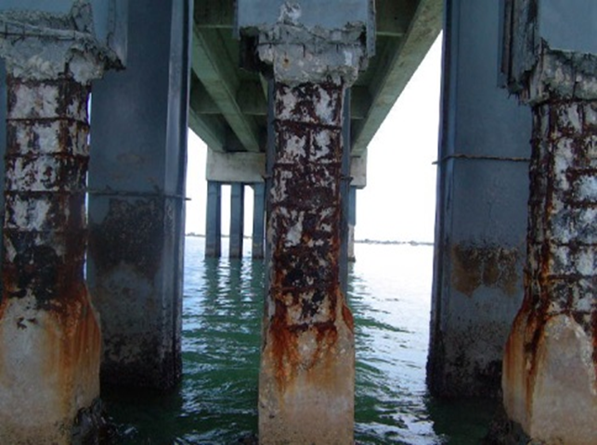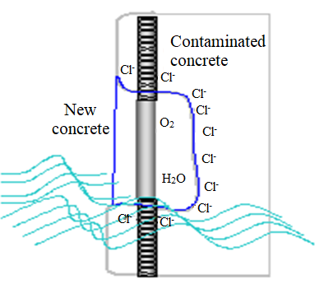
Figure 1. Repairing concrete structures using stainless steel proposed by Pérez Quiroz, (2009)

- EXPERIMENTAL PROCEDURE.

The materials and processes applied in this project were selected under two criteria: cost of the joint(s) and feasibility for field application of the welding process and electrodes. Table 1 lists the materials, equipment, and chemicals that were used in this research, and Table 2 provides the chemical compositions of the base metals, 309L electrode, and Inconel filler metal.

Table 1. Materials, equipment, and chemical solutions.
Materials | Equipment | Chemical solutions
ASTM A615 reinforcement bars.  AISI 304 reinforcement bars.  ER 309L electrode  Inconel 182 electrode | Saw cutting machine  Automatic disc cutting machine  Conventional lathe machine  Conventional milling machine  Castolin Eutectic, Master NT2000 AC/DC welding machine  Electro discharge machine  Grinding double disc machine  Polishing double disc machine  Magnetic heater  Fluke multimeter  Gamry interface1000 equipment  Reference electrode Ag/AgCl | 3.5 weight % Sodium chloride solution (NaCl) (sea water).  Saturated solution calcium hydroxide (Ca(OH)₂)

Table 2. Chemical compositions of base metals, 309L electrode and Inconel filler metal.

Steel | C | Si |  |  | Mn |  | P | S | Cr |  | Mo |  | Ni | Al | Co |  | Cu | Fe
ASTM A 615 | 0.24 | 0.18 |  |  | 0.77 |  | 0.03 | 0.03 | 0.08 |  | 0.04 |  | 0.07 | 0.01 | 0.01 |  | 0.23 | 98.3
AISI 304 | 0.01 | 0.33 |  |  | 1.39 |  | 0.07 | 0.03 | 18.1 |  | 0.27 |  | 8.61 | 0.01 | 0.18 |  | 0.38 | 74.1
Element | C |  |  | Mg |  |  |  | Si |  |  | Cr |  |  | Ni |  |  | Fe
Composition 309L (%) | 0.03 |  |  | 1.92 |  |  |  | 0.80 |  |  | 23.8 |  |  | 13.3 |  |  | Balance
Element | C |  | Si | Mn |  | P |  | S |  | Cr |  | Ni |  | Nb |  | Fe | Ti
Composition Inconel (%) | <0.1 |  | <1 | 5-9.5 |  | <0.03 |  | <0.015 |  | 13-17 |  | >59 |  | 1-2.5 |  | <10 | <1

The identification of the samples was made as indicated in Table 3.

Table 3. Designations of test samples.
Designation | Type of sample
A.C. SW | ASTM A615 carbon steel in NaCl 3.5% wt solution
A.I. SW | AISI 304 stainless steel in NaCl 3.5 % wt solution
A.C. HC | ASTM A615 carbon steel in calcium hydroxide
A.I. HC | AISI 304 stainless Steel in calcium hydroxide
Dissimilar welded joint BsAM1 | Single bevel joint without buttering in NaCl 3.5 % wt solution
Dissimilar welded joint BcAM2 | Single bevel with buttering in NaCl 3.5 % wt solution
Dissimilar welded joint BsHC1 | Single bevel joint without buttering in calcium hydroxide
Dissimilar welded joint BcHC2 | Single bevel joint with buttering in calcium hydroxide

The samples were carbon and stainless steel bars with the following dimensions: 1.9 cm in diameter and 10 cm in length (Figure 2). The bevel of the joint was prepared at 45°, in accordance with NMX-H-121-1988 and ANSI/AWS D1.4-M 2005. The welding process for the joints was Shielded Metal Arc Welding (SMAW), because this process is the most commonly used in field welding of reinforcement bars.

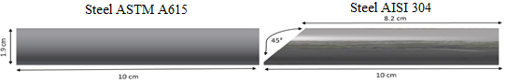

Figure 2. Diagram of a welded joint with a single bevel at 45°.

The applied filler metal for the welded joints was AISI 309L stainless steel. In the case of buttering welding, the electrode was Inconel 182. This step consisted of applying a 2 mm thick layer on the frontal surface of the AISI 304 bar. The welding machine was a Castolin Eutectic, Master NT2000 AC/DC and the welding parameters are given in Table 4.

Table 4. Welding parameters.
Diameter of the bar (mm) | 19
Diameter of the electrode (mm) | 3.2
Electric potential (V) | 22
Welding intensity (A) DC-PI | 90-95
Welding speed (mm/min) | 45
Heat input (kJ/mm) | 2.5
After welding, the samples were longitudinally and transversally cut with an ACTSPARK electrical discharge machine. The samples were mounted in epoxy and then prepared for metallography according to ASTM E 3. Before polishing, the stainless steel base metal of each sample was drilled to introduce a copper wire to achieve the electrical contact necessary for electrochemical testing. The corrosion behavior of the welded dissimilar joint was evaluated with a Gamry Interface 1000 potentiostat (Figure 3) by applying the following electrochemical techniques: measurement of corrosion potential according to ASTM C 876; linear polarization resistance test in accordance with ASTM G 59, and electrochemical noise measurement under ASTM G 199.

Linear Polarization Resistance (LPR)
This technique consists of measuring the relationship between the potential and the current density in steady state, exciting the system by application of direct-current signals. To perform the Rpl test, a three-electrode cell was used: the reference (Ag / AgCl), an auxiliary electrode (graphite), and the working electrode was an AC / SS specimen. The aforementioned electrodes were placed in the cell and the Rpl test was performed using the Gamry interface1000 potentiostat with the following settings: scanning of +/- 20 mV with a scanning rate of 10 mV / min, in accordance with ASTM G 59.

Electrochemical Noise (EN)
Electrochemical noise is a technique that measures the spontaneous fluctuations of the potential and the current in electrochemical systems, which are of low frequency (<10 Hz) and amplitude. Electrochemical noise originates, in part, from natural variations in electrochemical kinetics during a corrosion process. Frequently, EN is considered and analyzed as a random (stochastic) phenomenon coupled to deterministic kinetics.
The EN technique was performed with the help of a Gamry Interface 1000 potentiostat. This equipment is capable of measuring in real time the oxide-reduction phenomena that occur in the electrodes. The number of readings per test piece was 2048, with stabilization time of 10 seconds; the test time was 45 min. This test requires three electrodes, two identical ones, which consisted of silver / silver chloride Ag / AgCl, and a reference.

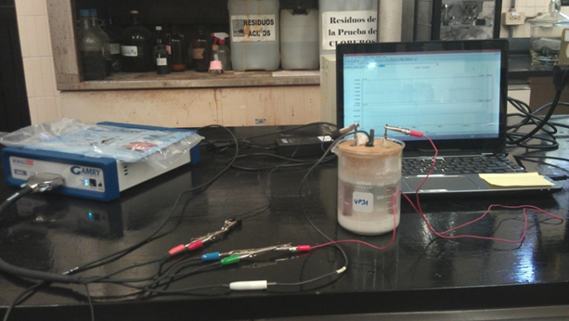
Figure 3. Electrochemical cell setup for corrosion tests.

- RESULTS AND DISCUSSION.

Before electrochemical testing, the samples were observed using a stereoscopic microscope, and cracks were observed in the samples where buttering was carried out (Figure 4); those cracks (approximately 2 mm in length) are associated with hot cracking owing to the nickel content in the Inconel 182 used for buttering. Recall that buttering is applied to dissimilar welded joints in order to prevent carbon diffusion, phase segregation, and chromium carbides precipitation, as these phenomena influence corrosion behavior in stainless steel. The results match those of Evans (1962), who reported that nickel alloys welded to stainless steel are susceptible to hot cracking. The macrographs in Figure 4 show some lack of fusion near the carbon steel/filler metal/ buttering interface. Such defects should not influence the corrosion behavior of the welded joint because they are located in the interior of the metal, but if the electrolyte were to make contact with them, they would become an anode and would allow localized corrosion. On the other hand, they have a strong impact on the mechanical properties because they act as stress risers / concentrators.

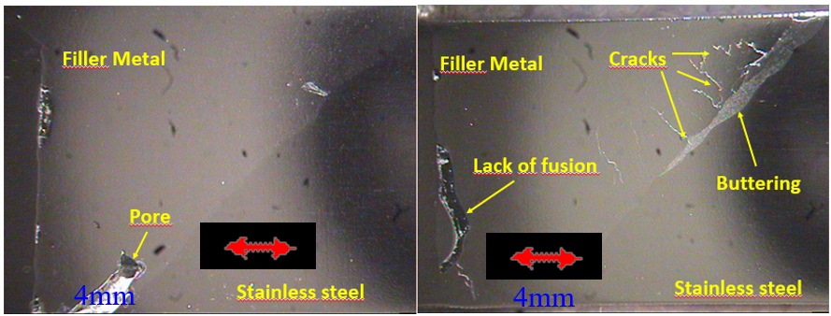
Figure 4. Samples at 7× magnification showing cracks and lack of fusion of the dissimilar welded joints.
3.1 Corrosion potential (Ecorr).
In Figure 5, the results of the corrosion potential of the base metals are shown. Measurements were carried out over 14 days for samples immersed in NaCl and Ca(OH)₂. In Figure 5, the more negative values occur for carbon steel in salt solution (A.C.), which simulates sea water. Such results indicate a high probability of corrosion under ASTM C 876 (2015). Sistonen (2002) indicated that such values represent a severe risk of corrosion. In the case of the stainless steel (A.I.), the results of the corrosion potential are more positive than for carbon steel in the same solution and in accordance with ASTM C876 (2015), the results fall within the uncertainty zone. Such results can be explained by the passive layer of chromite on the stainless steel, which protects the material to some extent. Sistonen (2002) suggested that the corrosion potential should be interpreted based on the criteria shown in Table 5.
In the case of the Ca(OH)₂ solution, the corrosion potential results for both base materials are more positive than in sea water because of the alkalinity of the Ca(OH)₂ solution, per the ASTM C 876 (2015) standard. The same standard mentions that the probability for damage of carbon steel in such environments is minimal. Based on Sistonen’s (2002) criteria, both steels are in the medium corrosion risk category.

Table 5. Criteria for corrosion potential of carbon steel and stainless steel (Sistonen, 2002).
Corrosion condition | Black Steel bar mV vs CSE | Stainless Steel bar mV vs CSE
Low corrosion Risk Around 10% | > - 200 | > - 100
Medium corrosion Risk | - 200 a - 350 | - 100 a -250
High corrosion Risk < 90% | - 350 a - 500 | -250 a - 400
Severe corrosion Risk | < - 500 | < - 400

Figure 6 shows the relationship between corrosion potential and time for single bevel welded joints in 3.5 wt % NaCl solution. The values fall within the high probability corrosion range according to ASTM C 876 (2015), but in accordance with Sistonen (2002), they fall within the range of severe corrosion risk. Note that the variation of the corrosion potential of sample BsAM2 was caused by experimental error, although the trend follows the other samples, where the corrosion risk is high.

Figure 5. Corrosion potentials of the base metals in sea water and calcium hydroxide.

Figure 6. Corrosion potential vs time in single bevel welded joints in sea water.

By comparing Figure 5 to Figure 6, it is not easy to detect any effect of the buttering on corrosion potential. However, such comparison indicates that the corrosion potential of an entire joint dropped to more negative values, which are very similar to the values of carbon steel immersed in sea water. These results indicate higher corrosion susceptibility.
Regarding samples in the sodium chloride (NaCl) and calcium hydroxide (Ca(OH)₂) solutions, the trend of the corrosion potential values with respect to time is between -0.500 V to -0.670 V vs. Ag/AgCl, because the more active metal is carbon steel (Figure 5) according to ASTM G 82. Because the corrosion potential of carbon steel is –approximately -0.600 V vs., and the stainless steel potential is -0.300 V vs. Ag/AgCl (Figure 5), the potential values shown in Figure 6 with respect to ASTM C876 indicate that there is a 90% probability of corrosion because they are more negative than -0.350 V vs. Ag/AgCl. Figure 6 also shows that the value of the corrosion potential is in the range of -0.500 V to -0.650 V vs Ag/AgCl.
Samples with higher numbers of defects (pores, cracks, etc.) were selected for testing in calcium hydroxide to investigate if they generated a passive layer, which reduces the corrosion rate. Figure 7 shows the results, indicating that after 15 days, the values are in the probable corrosion range according to ASTM C 876 (2015) and Sistonen (2002). However, after 20 days the corrosion potentials changed to more positive values. These results indicate that the corrosion process occurred during the first 14 days, after which a compact, adherent passive layer was formed on the surface of the samples owing to the alkalinity of the environment, according to ASTM C 876 (2015) and Sistonen (2002). Thus, based on these criteria, further corrosion damage in carbon steel, stainless steel, and the welded joint should be minimal. Note that for this test, samples with a higher number of defects were selected (with and without buttering). Thus, the results suggest that alkaline conditions lead to minimal damage due to corrosion in the case of reinforcement bars for concrete.

Figure 7. Potential vs time for single bevel welded joint in calcium hydroxide.

3.2 Measurements of corrosion rate based on polarization resistance.
Figure 8 shows the corrosion rates for the samples immersed in sea water, where all rates are in the range between 0.15 to 0.25 mm/y. The values are 10 times higher than the recommendations made by DURAR (1997). Thus, it can be stated that corrosion under these conditions is unavoidable for the base material and the filler metal. As mentioned previously, the electric connection of sample BsAM2 was lost, indicating why the values of that sample are almost zero.

Figure 8. Corrosion rate of single bevel welded joints in sea water.

Figure 9 displays changes in corrosion rate for calcium hydroxide, which are related to the beginning of the corrosion process and the possible passivation of the sample surfaces because of the alkaline medium in which the samples were tested.

Figure 9. Corrosion rates of single bevel welded joints in calcium hydroxide.

Figure 9 shows the corrosion rates of the welded joints immersed in a calcium hydroxide solution, which are many orders of magnitude lower than the corrosion rates in sea water (see Figure 8). As mentioned previously, this can be explained by the formation of the passive layer due to the alkaline environment of the solution, even with the welding defects shown in Figure 4. These facts support the argument that stainless steel is a good option for partly substituting carbon steel in reinforcement bars in concrete structures, as those shown in Figure 1. Moreover, assuming that stainless steel bars were embedded in new concrete, the material would already be passivated and severe corrosion damage would not occur quickly. The previous statement is justified by the Pourbaix (1966) diagram of iron, which indicates that in the alkaline ranges, it is protected by passivation.
Researchers such as Medina (2012), Bastidas (2014), Velasco (2013), Sanchez (2013), Bautista (2013), Acosta (2013), Landmann (2013), Andrade (1993), and González (1984) have reported good performance of stainless steel even in saline environments, because the dangerous corrosion rate level for concrete structures (100–125 μm/y) is higher than the results they obtained for stainless steel. Figure 8 verifies that the corrosion rates of the samples are higher than the recommended range of rates, while Figure 9 indicates corrosion rates are substantially lower than those ranges. Thus, repairs using stainless steel would meet the specification for an alkaline environment.

3.3 Measurements of corrosion rate by electrochemical noise.
The metallurgical effect of corrosion behavior on welded joints was evaluated using electrochemical noise. This technique consists of setting two electrodes in an electrolyte as described in Chapter 2 of ASTM C 199 and is shown in Figure 3. The results of this technique are shown in Figures 10–13. Two variables characterize the corrosion behavior of the samples: noise resistance (Rn), which is equivalent to polarization resistance; and the second variable is the localization index (I_{L}), which points out the corrosion form of the samples. The following criteria apply: uniform corrosion (0.001 to 0.01), mix between uniform and localized corrosion (0.01 to 0.1), and finally localized corrosion (0.1 to 1). Those criteria have been previously considered by Eden (1987), Kelly (1996), Mansfeld (1999), and Balán (2017).
Figure 10 shows that the values of I_{L} of the BsAM samples are in the localized corrosion range. Recall that those samples had no buttering layer and were immersed in sea water. Therefore, corrosion is expected in those samples. Figure 11 shows that the corrosion products are on specific spots of the sample surfaces, as predicted by ASTM G 199.
Although the values of I_{L} of the BcAM samples are in the localized corrosion range, the corrosion products are uniformly distributed on the sample surfaces, which agree more closely with the mixed corrosion criterion. This suggests that buttering leads to more uniform corrosion. The general scientific consensus is that uniform corrosion is less aggressive than pitting and crevice corrosion, because the latter types of corrosion cause structural damage and can lead to catastrophic failure.
Figure 10. Results of electrochemical noise testing of BsAM and BcAM samples in seawater.

Sample | Sea water 3.5wt% NaCl solution
BsAM1 | 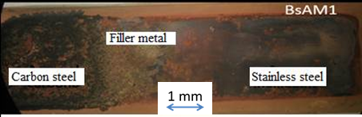
BsAM2 | 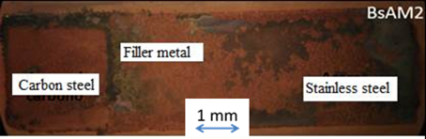
BcAM1 | 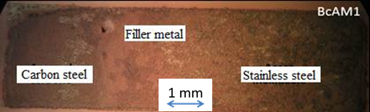
BcAM2 | 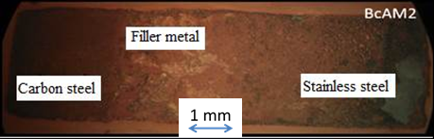
Figure 11. Stereographic images of BsAM and BcAM tested in sea water (3.5wt % NaCl solution). (Ramírez 2016)
Figure 12 shows the results of the samples tested in calcium hydroxide. Those results indicate localized corrosion occurs in the defects of the welded joint (as can be observed in Figure 13), where such corrosion occurs by the formation of differential aeration corrosion cells. Sample BsHC, which did not contain welding defects, exhibited a white layer on the surface of the welded joint (Figure 13), which inhibited corrosion. Therefore, the only places susceptible to localized corrosion were the welding defects.
In this case, the behavior of sample BsCH is related to the graph of Figure 12. This sample shows a corrosion tendency similar to BcCH because the results of both samples are in the localized corrosion range. However, in the case of BcHC it is considered that corrosion is associated with welding defects as well as with localized dissolution of the nickel layer. As explained by Pourbaix (1966), nickel corrodes slightly in alkaline solutions before forming a passive layer. The behavior of the BcHc sample agrees with this statement and explains the differences in the results between the two samples.
Figure 13 shows stereographic images of samples tested in calcium hydroxide, which were covered with a white color layer (calcareous deposit), which forms a passive layer on the samples’ surfaces.

Figure 12. Graph of I_{L} values for samples BsHC and BcHC tested in calcium hydroxide.

Nomenclature | Calcium hydroxide solution
BsHC1 | 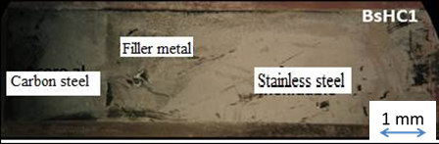
BsHC2 | 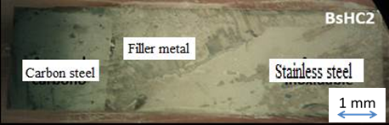
BcHC1 | 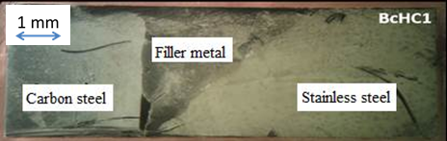
BcHC2 | 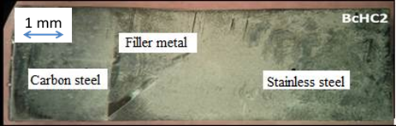
Figure 13. Surfaces of BsHC and BcHC samples after testing in calcium hydroxide. (Ramírez 2016)

Resistance noise (Rn) is a very powerful tool to assess the low corrosion rate of the BsHC and BcHC samples immersed in calcium hydroxide, and is similar to polarization resistance. Therefore, this technique was applied to those samples and the results are shown in Figures 14 and 15. ASTM G 102 (2015) specifies the relationship between Rp and i_{corr}, which is inversely proportional. In other words, the higher the values of noise resistance, the lower the corrosion current density, indicating a lower corrosion rate. Samples in sea water (NaCl 3.5wt% solution) exhibited lower noise resistance values than the samples in the Ca(OH)₂ solution, thus had a higher corrosion current density, indicating higher corrosion rates. Figures 14 and 15 highlight these results. The results agree with the results reported by Kelly (1996) and Garcia (2014).

Figure 14. Resistance in noise (Rn) of the BsHC and BcHC samples tested in saline solution.

Figure 15. Values of Rn for BsHC and BcHC tested in calcium hydroxide.

- CONCLUSIONS

The results of this work indicate that refurbishing of concrete structures using stainless steel is feasible, particularly if the steel is passivated. The construction or repair of a concrete structure must be carried out following the applicable standards in order to verify that the repaired area undergoes passivation to reduce future corrosion.
Measurements of corrosion potential were useful to determine the corrosion behavior in two different environments for bars made of carbon steel, stainless steel, and a dissimilar metal welded joint between the two materials buttered with Inconel 182 and without buttering. It was found that carbon steel in sea water is susceptible to corrode with 90% probability, while stainless steel is in the range of uncertainty. However, essentially opposite results were obtained for an alkaline environment (Ca(OH)₂ solution), where the probability of corrosion was 10%.
Both dissimilar welding joints with and without buttering resulted in a 90% probability of corrosion in sea water, while in the alkaline media the probability of corrosion for either joint decreased to 10%. This was explained by a passive layer found on the sample surfaces.
The corrosion rate of the welded joint with buttering was lower in an alkaline environment (Ca(OH)₂ solution) than in sea water (NaCl 3.5 wt% solution). These results were also explained by formation of a passive layer on the surface defects of the samples in the alkaline environment.
The results of electrochemical noise were used to describe electrochemical behavior in the alkaline solution and in sea water of welded joints with and without buttering. The results indicated that the corrosion type on such samples was mixed corrosion, and they match the results obtained by polarization resistance and corrosion potential measurements.

- REFERENCES

Acosta, P., Matres, V., Pachón, A., Sánchez, J., Fullea, J., Picón, J. M. (2013). “Armaduras de acero inoxidable expuestas en ambiente marino. Caracterización in-situ de la corrosión”. DM Bastidas, E. Medina Sánchez, CEDINOX (Eds.), Armaduras Acero Inoxidable, CEDINOX, Madrid (España), 115-128.
Molina, F.J., Alonso, C., Andrade, C. (1993), “Cover cracking as a function of rebar corrosion: Part 2—Numerical model”, Materials and Structures 26, 532. DOI: https://doi.org/10.1007/BF02472864
American National Standards - American Welding Society (2005) ANSI/AWS D1.4-M Structural Welding Code - Reinforcing Steel.
ASTM International. (2014). ASTM G59-97(2014) Standard Test Method for Conducting Potentiodynamic Polarization Resistance Measurements. Retrieved from https://doi.org/10.1520/G0059-97R14
ASTM International. (2014). ASTM G199-09(2014) Standard Guide for Electrochemical Noise Measurement. Retrieved from https://doi.org/10.1520/G0199-09R14
ASTM International. (2015). ASTM C876-15 Standard Test Method for Corrosion Potentials of Uncoated Reinforcing Steel in Concrete. Retrieved from https://doi.org/10.1520/C0876-15
ASTM International. (2015). ASTM G102-89(2015)e1 Standard Practice for Calculation of Corrosion Rates and Related Information from Electrochemical Measurements. Retrieved from https://doi.org/10.1520/G0102-89R15E01
ASTM International. (2017). ASTM E3-11(2017) Standard Guide for Preparation of Metallographic Specimens. Retrieved from https://doi.org/10.1520/E0003-11R17
Balán-Ortiz, C. A., Luna Brito, M., Pérez López, T.; Camacho-Chab, R.J. (2017) “Análisis estadístico de los registros de ruido electroquímico obtenidos del proceso de corrosión del acero de refuerzo embebido en concreto”, Revista Mexicana de Ingeniería Química 2017, 16 (1). ISSN 1665-2738, Disponible en: https://www.redalyc.org/articulo.oa?id=62049878028
Baltazar, M., & Almeraya, F., Nieves, D., & Borunda, A., Maldonado, E., Ortiz, A. (2007). “Corrosión del acero inoxidable 304 como refuerzo en concreto expuesto a cloruros y sulfatos”. Scientia Et Technica, 13 (36), 353- 357. Disponible en: https://www.redalyc.org/html/849/84903663/
Bastidas, D. M., Zapico, C. (2014). “Comportamiento frente a la corrosión de armaduras de acero inoxidable dúplex en solución simulada de poros de hormigón con elevado contenido de cloruros”. Industria química, ISSN 2340-2113, Nº. 17, 2014, págs. 68-74
Bautista, A., Paredes, E. C., Velasco, F. (2013). “Influencia del corrugado en la durabilidad de las barras austeníticas en medios sin carbonatar y con cloruros”. Armaduras de Acero Inoxidable, ISBN 978-84-695-8183-4, págs. 105-114
Bertolini, L., Gastaldi, M., Pastore, T., Pedeferri, M. P., Pedeferri, P. (1998). Effects of
galvanic coupling between carbon steel and stainless steel reinforcement in concrete. International
Conference on “Corrosion and Rehabilitation of Reinforced Concrete Structures”, Federal Highway Administration, Orlando. December 7–11
Brown, B. L., Harrop, D., Treadaway, K.W.J. (1976) “Corrosion Testing of Steels for Reinforced Concrete Corrosion Testing and Monitoring”, Reprint
British Stainless Steel Association (BSSA) (2003) “The Use of Stainless Steel Reinforcement in Bridges”, Special BSSA Report - April 2003, Disponible en: https://www.bssa.org.uk/cms/File/REBar%20report.pdf
Eden, D. A., John, D. G., Dawson, J. L. (1987), Corrosion monitoring. International Patent WO 87/07022. World Intellectual Property Organization, 19.
Evans, R. M. (1962). “Joining of Nickel-Base Alloys”, (No.181). DMIC Report 181, Battelle Memorial Institute, Columbus 1, Ohio
Doddy, T. (1992), "Intermediate mixed zones in dissimilar metal welds for sour service", Welding Journal, 71 (3), pp. 55-60.
DURAR (1997). Manual de inspección, evaluación y diagnóstico de corrosión en estructuras de hormigón armado. CYTED, Programa Iberoamericano de Ciencia y Tecnología para el Desarrollo, Subprograma XV Corrosión/Impacto Ambiental sobre Materiales Maracaibo, Venezuela, ISBN 980-296-541-3.
García Fuentes, A., Centeno, L., Salas García, R., Velazquez Del Rosario, A. (2011). Metalurgia de uniones soldadas de aceros disímiles (ASTM A240–A537) y comportamiento mecánico ante cargas monotónica y cíclica, Revista Latinoamericana De Metalurgia Y Materiales, 2012, 32(1). Recuperado de http://www.rlmm.org/ojs/index.php/rlmm/article/view/113
García, I. L. (2014). “Caracterización electroquímica del acero al carbono e inoxidable en soluciones concentradas con extracto de cemento”; Tesis que para obtener el Grado de: Maestría en Ciencias de Materiales.
González Díaz, F. (2010). “Realcalinización electroquímica del concreto reforzado carbonatado: una opción de prevención contra la corrosión”. Doctoral dissertation, Universidad Autónoma de Nuevo León.
González, J. A., Andrade, C., Escudero, M. L., (1984), “Corrosión de las armaduras por carbonatación del hormigón”. Rev. Iberoamericana de corrosión y protección 15 (4), 11-19.
Kelly, R. G; M. E. Inman, J. L. Hudson, (1996) “Analysis of Electrochemical Noise for Type 410 Stainless Steel in Chloride Solutions (STP 1277)”, STP 1277 Electrochemical Noise Measurement for Corrosion Applications (ASTM International), pp. 101-113 DOI: https://doi.org/10.1520/STP37954S
Kepler, J. L., Darwin, D., Locke Jr, C. E. (2000). Evaluation of corrosion protection methods for reinforced concrete highway structures (No. K-TRAN: KU-99-6,). Kansas Department of Transportation
Landmann, M. S., Fuentes, J. R., Bonaste, V., & Martínez, A. S. (2013). “Rehabilitación con armaduras de acero inoxidable”. In Armaduras de acero inoxidable (pp. 167-190). ISBN 978-84-695-8183-4
Terradillos, P. G., Llorca, M. Á. C., Gómez, E. Z. (2008). “Corrosión de Armaduras en estructuras de Hormigón Armado”. Editorial Club Universitario. ISBN: 978-84-8454-685-6, Sapin.
Lundin, C. D. (1982). Dissimilar metal welds-transition joints literature review. Welding Journal, 61(2), 58-63. URL: http://files.aws.org/wj/supplement/WJ_1982_02_s58.pdf
Mansfeld, F., Sun, Z. (1999), Technical Note: Localization Index Obtained from Electrochemical Noise Analysis. Corrosion Science, 55 (10) pp. 915-918 DOI: https://doi.org/10.5006/1.3283926
Medina, E., Cobo, A., Bastidas, D. M. (2012). “Evaluación del comportamiento estructural y de resistencia a la corrosión de armaduras de acero inoxidable austenítico AISI 304 y dúplex AISI 2304 embebidas en morteros de cemento Pórtland”. Revista de Metalurgia, 48(6), 445-458. DOI: https://doi.org/10.3989/revmetalm.1203
Medina, E. D. B. (2013). “Introducción a las Armaduras de acero inoxidable”, 1-22. URL: http://hdl.handle.net/10261/85075
McDonald, D. B., Pfeifer, D. W., Sherman, M. R. (1998), Corrosion evaluation of epoxy-coated, metallic-clad, and solid metallic reinforcing bars in concrete, Report No. FHWA-RD-98-153, Federal Highway Administration, McLean, VA, December, 137 pp. URL: https://trid.trb.org/view/496237
NMX-H-121 (1988) “Procedimiento de soldadura estructural acero de refuerzo”. Dirección general de normas.
Nurnberger U, (1996), “Stainless steel in concrete”. European Federation of Corrosion publications, No. 18. London, Institute of Materials.
Ospina Lopez, R., Aguirre Corrales, H., Parra, H. (2007). “Soldabilidad en aceros inoxidables y aceros disimiles”. Scientia et technica, 13(34). Disponible en: https://www.redalyc.org/articulo.oa?id=84934046
Pedeferri, P., Bertolini, L., Bolzoni, Pastore, F. T. (1997), “Behavior of Stainless Steels in Concrete,” Proceedings of the International Seminar: The state of the art of the repair and rehabilitation of reinforced concrete structures Eds. W.F. Silva-Araya, O.T. DE RINCÓN, and L. P. O’Neill, (Reston, VA: ASCE, 1997): p.192.
Pérez. L.T. (2002). “Pérez. L.T. (2002). “Aplicación de la Técnica de Espectroscopia de Impedancia Electroquímica en el Estudio de la Corrosión del Acero de Refuerzo Embebido en Concreto”. Programa de Corrosión del Golfo de México.
Pérez-Quiroz, J. T., Alonso-Guzmán, E. M., Martínez-Molina, W., Chávez-García, H. L., Rendón Belmonte, M., Martínez-Madrid, M. (2014), “Electrochemical Behavior of the Welded Joint Between Carbon Steel and Stainless Steel by Means of Electrochemical Noise”, International Journal of Electrochemical Science, pp. 6734 – 6750.
Pérez Quiroz, J. T. (2009), “Evaluación de acero inoxidable para la rehabilitación de estructuras de concreto reforzado”. Tesis para obtener el grado de Doctor en Ingeniería Química.
Pourbaix, M. (1966), Atlas of electrochemical equilibria in aqueous solutions. Pergamon Press, New York.
Ramírez-Soto, J. C. I., Salgado-López, J. M., Pérez-Quiroz, J. T., Pérez-López, T., Terán-Guillén, J., & Martínez-Madrid, M. (2016). “Effect of buttering in mechanical properties of dissimilar metal weld joints for reinforcement bars in concrete structures”. Revista ALCONPAT, 6(3), 248-261.
Schierloh, M., Rougier, V., & Souchetti, R. (2010). “Vigas de hormigón armado afectadas por corrosión y reparadas con materiales de matriz polimérica reforzados con fibras (PRFS)”. IX Jornada “Técnicas de restauración y conservación del patrimonio”.
Sánchez, E. M., Llorente, I., Fajardo, S., Bastidas, D. M. (2013), “Comportamiento frente a la corrosión por cloruros de una nueva armadura de acero inoxidable dúplex de bajo contenido en níquel”, Armaduras de acero inoxidable, ISBN 978-84-695-8183-4, págs. 91-103, Editores: CEDINOX, Centro para la investigación y desarrollo del acero inoxidable.
Sistonen, E., Tukiainen, P., Peltola, S., Skriko, S., Lastala, M., Huovinen, S. (1998-200), Improvingthe durability of reinforced outdoor concrete structures by restricting cracksand protecting reinforcement, part I & II. Project 1998–2002
Soerensen, B., Jensen, P. B., Maahn, E. (1990), The corrosion properties of stainless-steel reinforcement. Corrosion of Reinforcement in Concrete. Ed. by C. L. Page, K. W. J. Treaday, P. B. Bamforth. Papers Presented at the Third International Symposium on "Corrosion of Reinforcement in Concrete Construction", Belfry Hotel, Wishaw, Warwickshire, May 21-24, 1990
Treadaway, K. W. J., Cox, R. N., Brown, B. L. (1989), Durability of corrosion resisting steels inconcrete. Proceedings Institution Civil Engineers, 86, pp.13–27.
Velasco Lopez, F. J., Alvarez Arboleda, S. M., Bautista Arija, M. A. (2013), Comportamiento frente a la corrosión de corrugados dúplex de baja aleación en disoluciones simuladas de poros de hormigón. In: Armaduras de acero inoxidable, pp. 81-90, ISBN: 978-84-695-8183-4

